Home Screen

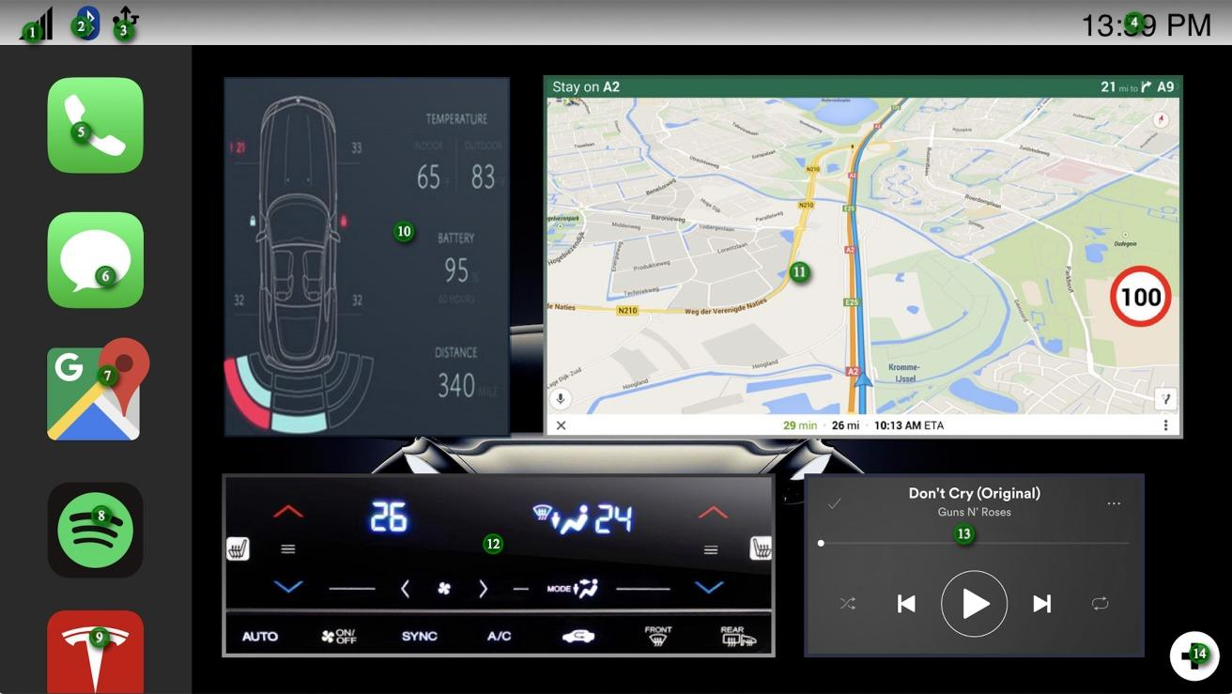

|  |  |  |
| --- | --- | --- |
| NO # | Icon name | functionality |
| 1 | **The bar icon** | Displays the signal strength of cellular reception |
| 2 | The Bluetooth icon | Bluetooth is activated, click to deactivate |
| 3 | The USB icon | USB connection detected |
| 4 | Date & Time | Displays current time, click to set time |
| 5 | The call icon | Click to open the call application |
| 6 | The messenger icon | Click to open the messenger application |
| 7 | Map Icon | Click to open maps on the main screen |
| 8 | Spotify Icon | Click to open Spotify Music Application on the main screen |
| 9 | Tesla Icon | Click to open Tesla vehicle system information on the main screen. |
| 10 | Vehicle system status | Displays vehicle sensors, locked doors, current battery, mileage left on battery, temperature  (inside & outside). Click to open Tesla vehicle system information on the main screen |
| 11 | Google maps | Displays current route, click to enlarge Maps on the home screen. |
| 12 | Comfort Systems | Displays the set temperature as well as ac systems. All settings are adjustable. |
| 13 | Music shortcut | Displays current playing music with pause, next and previous functionality, click top open Spotify music application. |
| 14 | Add Icon | click to add more applications on the home screen |

**Comfort System**

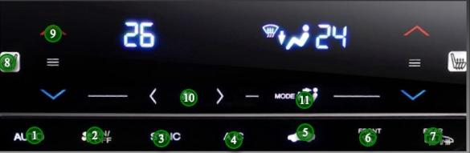

|  |  |  |
| --- | --- | --- |
| NO # | icon | Functionality |
| 1 | Auto | click to set air conditioning temperature to auto |
| 2 | Fan | Click to turn fan on / off |
| 3 | Sync | Click to sync air conditioning control |
| 4 | A/C | Turn A/C On/Off |
| 5 | airflow | click to turn ariflow On/Off |
| 6 | front windscreen | Click to turn on front windscreen heater |
| 7 | airflow | click to turn on front windscreen heater and airflow |
| 8 | left seatheater | Click to turn on left seat heater |
| 9 | heat Adjuster | Click to adjust seat warmer temperature |
| 10 | Fan Adjuster | Click to adjust fan speed |

Google Maps

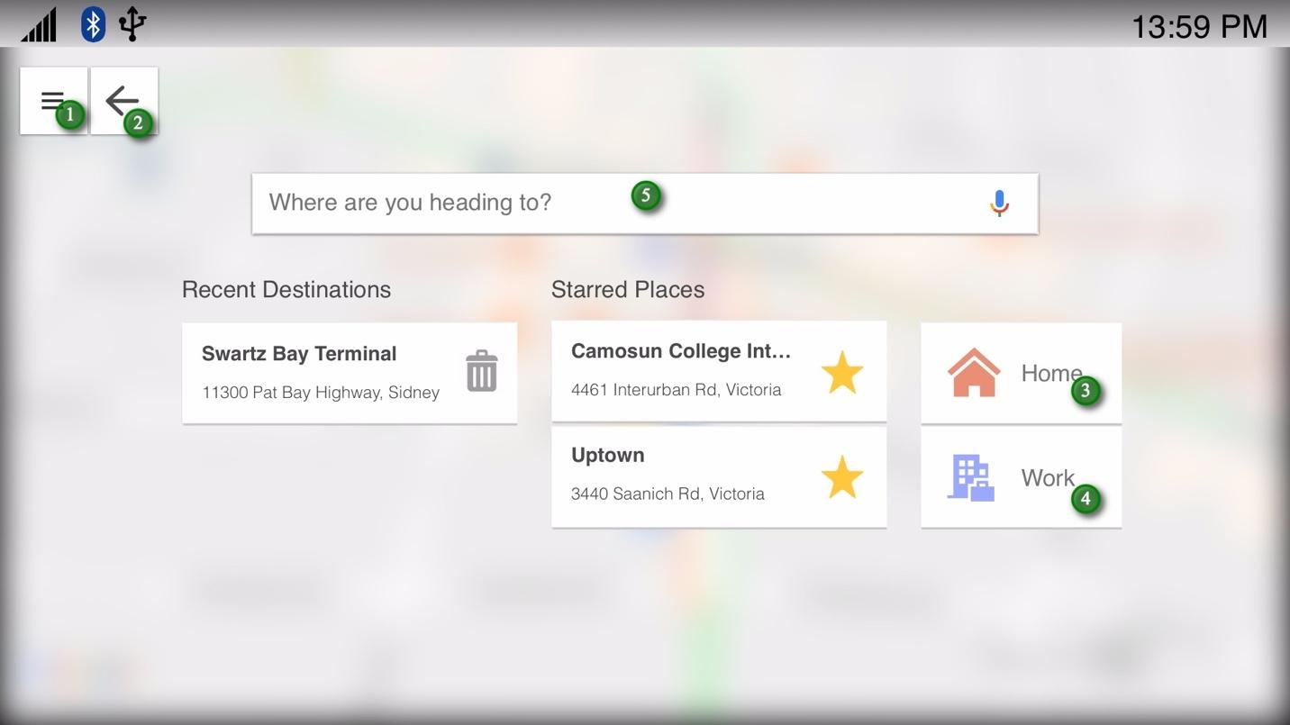

|  |  |
| --- | --- |
| No # | Functionality |
| 1 | Click to open map settings |
| 2 | Click to go back to home screen |
| 3 | Click to set home destination |
| 4 | Click to set work destination |
| 5 | Click to enter address search |